**LAB NO:07**

**OBJECTIVE:** TO UNDERSTAND MULTITHREADING

TASK:MATRIX MULTIPLICATION

Execute it and print the time at start and at the end.

SIMPLE MATRIX MULTIPLICATION WITHOUT THREADS.

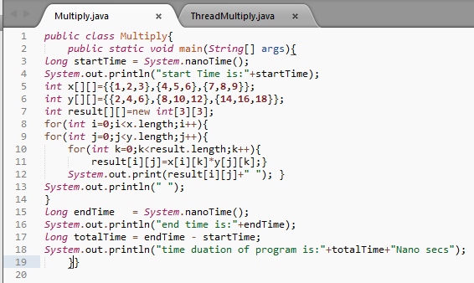

OUTPUT:

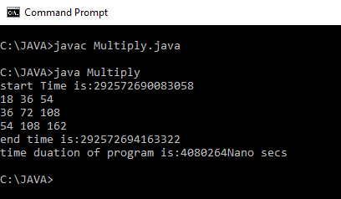

TASK: MATRIX MULTIPLICATION

Write the same code for matrix multiplication and divide the code into ten threads. Also note the timestamp at the start and end of the program. Give your conclusion.

MATRIX MULTIPLICATION USING THREADS:

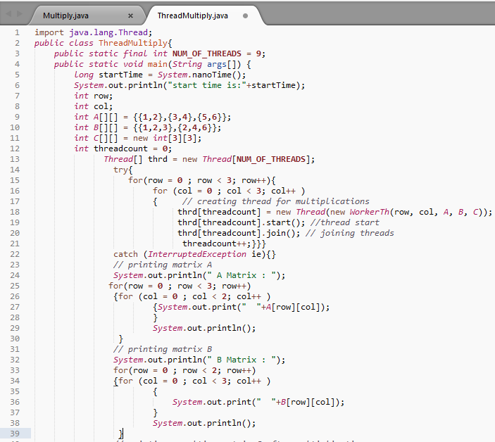

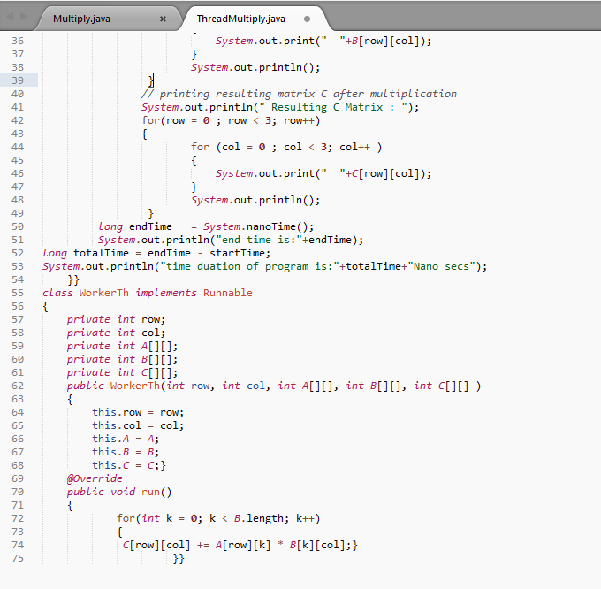

OUTPUT:

